# Environment

Mac OS 11.6 Big Sur

Node JS 10.16

Npm 6.11

# Electron Setup

Executed this commands below to initiate npm packages.

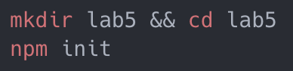

After that, a bunch of node modules has been downloaded.

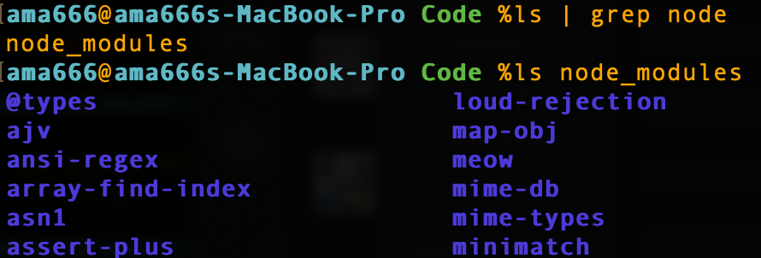

Modify information in package.json file, add “start:electron” under scripts.

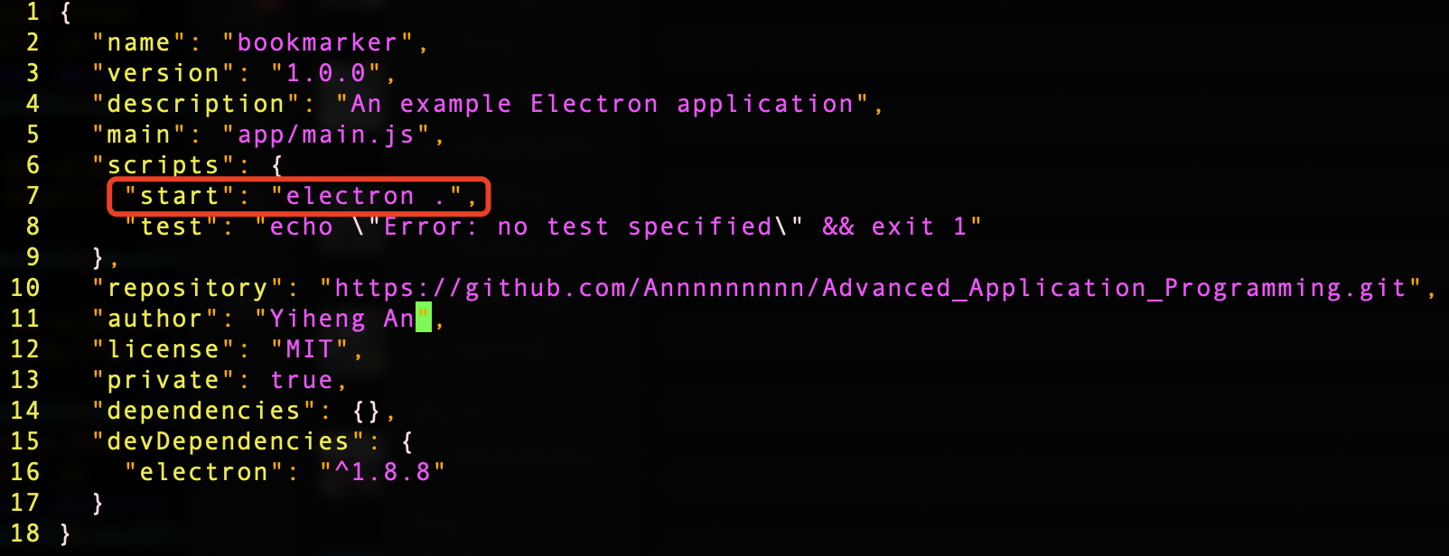

Then, create three files under this directory. main.js which is the main process of the electron, index.html is the index page of the app, renderer.js is what I write my javascript function and loaded into index.html.

## Index.html

I designed three function on this app. The first on is a bookmark function. It allows you input a URL and store this URL as a bookmark. And the second function is from lab 3, it can find prime number. It takes user’s input and return all prime number from 0 to this number. The last function is a image upload preview function. It allows user upload a image and preview it on the web page.

I used two ways to call javascript functions. One is use renderer.js file. As the name implies, after the main process is added to index.html, the index page is dynamically rendered through the user's click operation. Another method is to directly drink the javascript code into index.html and call the function through the event attribute in the html tag.

## renderer.js

Render is equivalent to a module of electron. By defining functions in this file, the index page can call functions in the render module just like calling object methods.

## imgUpload.js & findPrime.js

These two files are traditional javascript functions, one of which is migrated from lab3, and the other is a newly added function. Both files define functions with different functions in them, and the functions can be called directly after the two files are loaded in the index page.

# Run

The whole Code directory structure is like this.

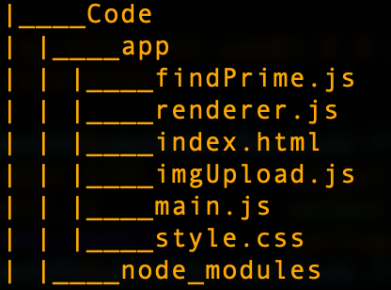

Execute these commands.

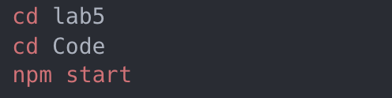

Input a valid URL and click Submit.

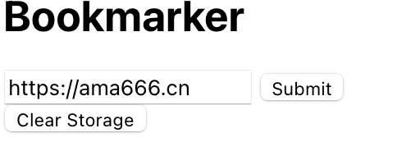

This URL has been added to the bookmark.

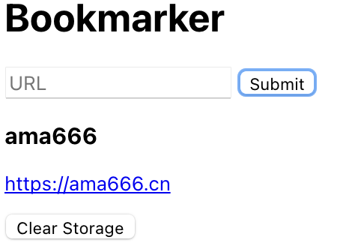

Input a positive number and click Submit. All prime number from 0 to this number will be displayed.

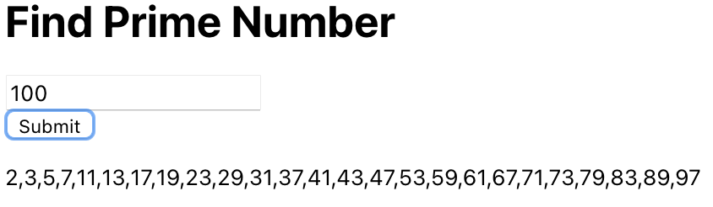

Click Choose File and choose a picture. The picture you chose will be displayed below.

